**Task** **1:**

Task Description #1

* Use Google Gemini in Colab to write a Python function that reads a list of numbers and calculates the mean, minimum, and maximum values.

Expected Output #1

* Functional code with correct output and screenshot.
* Promot: write a Python function that reads a list of numbers and calculates the mean, minimum, and maximum values.

Code:

Output:

Task Description #2

* Compare Gemini and Copilot outputs for a Python function that checks whether a number is an Armstrong number. Document the steps, prompts, and outputs.

Expected Output #2

* Side-by-side comparison table with observations and screenshots.

|  |  |  |
| --- | --- | --- |
|  | **Gemini AI** | **Copilot AI** |
| **CODE:** |  |  |
| **OUTPUT:** |  |  |
| **OBSERVATION:** | **AI Gemini I gave a prompt** Python function that checks whether a number is an Armstrong number.  **It give perfect code to run.** | **In Copilot AI:**  Python function that checks whether a number is an Armstrong number.  **The given code was not running .** |

**Task 3:**

Task Description #3

* Ask Gemini to explain a Python function (e.g., is_prime(n) or is_palindrome(s)) line by line.
* Choose either a prime-checking or palindrome-checking function and document the explanation provided by Gemini.

Expected Output #3

* Detailed explanation with the code snippet and Gemini’s response.

**Code and Output:**

**Explanation by Gemini AI collab:**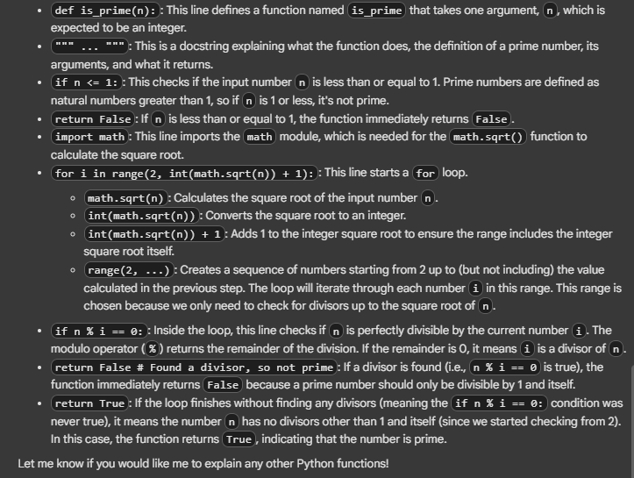

Task Description #4

* Install and configure Cursor AI. Use it to generate a Python function (e.g., sum of the first N natural numbers) and test its output.
* Optionally, compare Cursor AI’s generated code with Gemini’s output.

CODE:

**OUTPUT:**

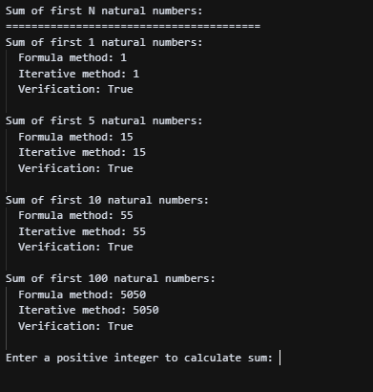

Task Description #5

* Students need to write a Python program to calculate the sum of odd numbers and even numbers in a given tuple.
* Refactor the code to improve logic and readability.

**CODE:**

**OUTPUT:**

